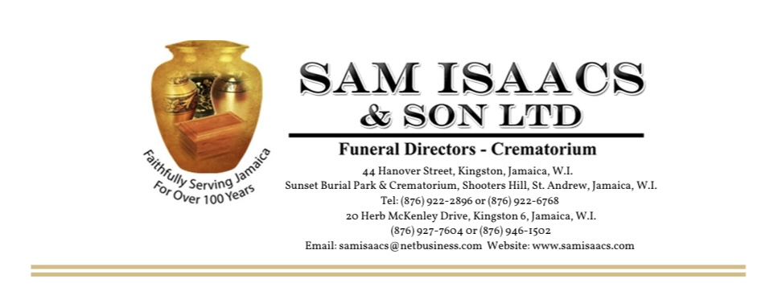

Suggested basic Programme Outline for Church of God, Pentecostal, Apostolic, Baptist, SDA & Chapel Services
(Not for the Anglicans & Catholics)
*This document MUST be reviewed and approved by the Officiating Minister / Pastor / Priest

Service of Thanksgiving/Funeral Service
For the Life of
……………………………………………………………………..
Date of Birth ………………….. Date of Death ……………………
at
Church / Venue…………………………………………………………………………….
Address………………………………………………………………………………………….
Day…………………… Date………… Month………………………. Year……………
Time…………………………………………………
Officiating Minister (a)…………………………………………………….
(b)……………………………………………………
(c) ……………………………………………………
Organist ……………………………………………………………………..
Interment Follows at ………………………………………………………
Order of Service
Musical Prelude
Opening Sentences …………………………………………………………
Opening Hymn…………………………………………………………………
Prayer………………………………………………………………………………
First Lesson………………………………………………………………………
Selection / Tribute in Song………………………………………………
Second Lesson………………………………………………………………..
Tributes 1……………………………………………………
2…………………………………………………...
3…………………………………………………..
Hymn……………………………………………………………….
Open Tributes:
Hymn………………………………………………………………….
Remembrance…………………………………………………….
Offertory Hymn………………………………………………….
Eulogy…………………………………………………………………..
Hymn / Choir Selection………………………………………...
Homily………………………………………………………………….
Prayer for the Bereaved Family…………………………….
Recessional Hymn…………………………………………………
At The Graveside
Hymn……………………………………………………………………
Hymn……………………………………………………………………
Choruses
1………………………………………………
2…………………………………………….
3……………………………………………
Pall Bearers
1------------------------- 4---------------------------------
2----------------------------- 5----------------------------------
3------------------------------ 6----------------------------------

ACKNOWLEDGEMENT

