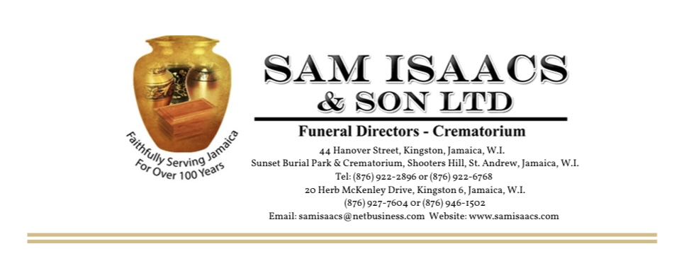
DEATH ANNOUNCEMENT/ OBITUARY

NAME OF DECEASED: _________________________________________________________

AKA (Also Known As): _________________________________________________________

AGE: _______________________________________________________________________

DIED/PASSED/TRANSITIONED ON: _______________________________________________

LEAVING (Relatives): __________________________________________________________

FUNERAL/THANKSGIVING SERVICE WILL BE HELD ON (DATE):

___________________________________________________________________________

AT (PLACE OF SERVICE): _______________________________________________________

___________________________________________________________________________

AT (TIME OF SERVICE): ________________________________________________________

PLACE OF INTERMENT/INURNMENT: _____________________________________________

___________________________________________________________________________

